**Charotar University of Science and Technology**

**Devang Patel Institute of Advance Technology and Research**

**Department of Computer Engineering**

|  |  |  |  |  |  |
| --- | --- | --- | --- | --- | --- |
| **Student ID** | **:** | **18DCE115** | **Student Name** | **:** | **KASHYAP SHAH** |
| **Subject Code** | **:** | **CE247** | **Subject Name** | **:** | **WEB TECHNOLOGY** |
| **Date of exam** | **:** | **26-05-2020** | **Semester** | **:** | **4th Semester** |

**Definition:**

**1)**Write a JavaScript function that accepts a string as a parameter and find the

longest word within the string.

Example string: 'Web Development Tutorial'

Expected Output: 'Development'.

**Solution (code):**

<html>

<head>

<title>Find the longest word within a string</title>

<script>

function longest_word(str)

{

var arr = str.match(/\w[a-z]{0,}/gi);

var result = arr[0];

for(var x = 1 ; x < arr.length ; x++)

{

if(result.length < arr[x].length)

{

result = arr[x];

}

}

return result;

}

document.write(longest_word('Kashyap Shah'));

</script>

</head>

<body>

</body>

</html>

**Input and Output Screen Shot:**

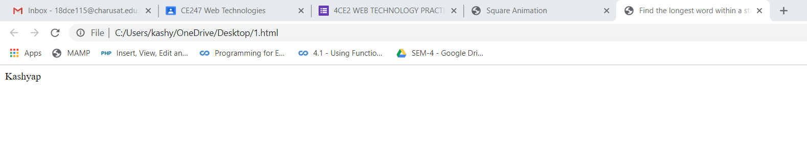

**Definition:**

**2)** Write a style sheet code for following tasks.

a. Move a Square in 4 direction using Animation in CSS3 and also

changing its color from red – blue – green – yellow.

**Solution (code):**

<html>

<head>

<title>Square Animation</title>

<style>

#animation

{

width:100px;

height:100px;

animation-name:demo;

animation-duration: 4s;

animation-iteration-count:infinite;

animation-delay: 0s;

animation-direction: normal;

animation-timing-function: ease-in-out;

position: absolute;

}

@keyframes demo

{

0%{background-color:red;top:0px;left:0px;}

25%{background-color:blue;top:0px;left:200px;}

50%{background-color:green;top:200px;left:200px;}

75%{background-color:yellow;top:200px;left:0px;}

100%{background-color:red;top:0px;left:0px;}

}

</style>

</head>

<body>

<div style="width:300px; height:300px; border:1px solid black; position:relative;">

<div id="animation">

</div>

</div>

</body>

</html>

**Input and Output Screen Shot:**

